**Searching For Secured Storage In The Cloud With Efficient Frequent Grammar.**

*1* *R. Priyanka, 2D. Sneha ,3*  *V. Kavya Sri, 4Mr.B.Samba Raju*

# *1,2,3bachelor Degree, Cse,* *Jayamukhi Institute Of Technological Sciences Narsampet, Warangal.*

*4Mr.B.Samba raju, Assistant Professor, bachelor Degree, Cse, Jayamukhi Institute Of Technological Sciences Narsampet, Warangal.*

**ABSTRACT:**

Cloud computing offers omnipresent data access and flexible data management. Customers do not, however, completely trust the cloud server's storage service. A key instrument for safe storage, searchable encryption might concurrently perform the tasks of secrecy protection and privacy-preserving data retrieval. In this research, we offer a strong, privacy-preserving, and resistant to off-line keyword guessing attack (KGA) big universe regular language searchable encryption technique for the cloud. The proposal's support for regular language encryption and deterministic finite automata (DFA)-based data retrieval stands out among other existing solutions. The system's extensibility is ensured by the big universe structure, which does not require a preset symbol set. The method allows for many users, and a user can create a DFA token using his own private key without involving a key generation centre. The concrete technique is also effective and officially demonstrated to be secure in the standard model. Numerous comparisons and simulations demonstrate that this strategy performs and functions better than other strategies.

**INTRODUCTION:**

Cloud storage [1] is a new type of storage that enables users of cloud computing to access scalable, elastic, and pay-per-use services. For personal use, subscribers get unlimited access to their data on any device, at any time, and from any location. When a team of users uses cloud storage [2], it enables team members to synchronise and manage all shared documents. Additionally, it spares the consumer a significant amount of capital expenditure on pricey storage equipment [3].

Cloud offers users ease, but it also creates several security and privacy issues [4], [5]. Customers cannot fully control their data because it is physically kept on the several servers of the cloud service provider. They are concerned about the security of the stored papers since a hacker may access the server or inside staff members could utilise the information for their own gain [6]. Customers would rather utilise encryption technology to safeguard the privacy of their data, but doing so raises another issue: how to carry out data retrieval on such a vast amount of cipher text. It would be absurd to demand that a cloud customer download all of their data, decrypt it, and then do a search on the recovered plaintext documents. The significant transmission overhead and the lengthy wait for the data retrieval result were intolerable for no consumer.

Searchable encryption technology [7, [8], and [9] protects data through encryption and allows effective search functionality without compromising data privacy. Using his private key, the data user creates a token for the material he wishes to search.

When the cloud server receives the token, it examines the encrypted data without first decrypting the cipher text. The most crucial aspect is that neither the sought content nor the plaintext of the encrypted data are revealed to the server during the data retrieval process. The majority of searchable encryption systems, however, only offer simple search methods like single keyword, conjunctive keyword, and boolean searches. A strong user experience is crucial since the cloud computing business is one with intense rivalry. Designing new searchable encryption techniques with expressive search patterns is urgently needed for cloud storage.

**Related Work:**

**Cloud Security 1.1.1**

Although cloud computing is thought to be a viable service mode for the next generation of networks, security and privacy worries remain the main roadblock preventing its widespread adoption in practical use. Chang et al.'s [10] investigation of the multi-layered security of cloud computing, which incorporates convergent encryption, access control, identity management, and firewalls. In order to implement safe access to remote-resident multimedia services, Zheng et al. [11] devised a mobile architecture.

Without downloading all the data, the proven data possession (PDP) technique for cloud computing offers a probabilistic proof way to demonstrate the user's data integrity.

In [13], [14], the PDP problem was addressed. Barsoum et al. [13] investigated the PDP structures' design philosophy.

and outlined the drawbacks of the current PDP models.

For multi-cloud storage, Wang et al. [14] presented an identity-based PDP model that removes the onerous certificate administration and allows for several methods of verification. The evidence of retrievability problem in the cloud with resource-constrained devices was researched by Li et al. [15]. They accomplished dynamic data operations and decreased the high computing cost of tag creation. accomplished dynamic data operations and much of tag generation. A novel secure storage in the cloud architecture was presented by Tiwari et al. [16] by combining evidence of retrievability and revocation. Omojte et al. [17] proposed a lightweight coding-based strategy to support several users.

1.1.2 DFA

A finite automaton has a set of states, and its "control" changes states in response to "inputs" from outside the automaton. the word The word "deterministic" in "deterministic finite automata (DFA)" refers to the notion that the automaton can transition from its current state to just one other state on each input [18]. (Subsection 2.3 has a detailed description of DFA.) An evolutionary technique for learning DFA that just evolves the transition matrix and employs a straightforward deterministic mechanism to best assign state labels was examined by Lucas et al. in 2005 [19]. According to Kobayashi et al. [20] introduced a novel method for expressing a DFA as a linear condition problem and linear inequalities with a manageable amount of unrestricted binary variables. A polynomial double inversion minimization technique may be produced via an automization procedure on a DFA with a time polynomial complexity, as demonstrated in 2013 by Parga and collaborators [21].

Later, to enable learning that was adaptive, Sarkar et al. [22] introduced DFA to the online instruction. In the e-learning courses, separate DFAs are created for various parts. Fernau et al. [23] studied two a NP- issues on DFA using the tools given by "Parameterized Complexity":Finding a DFA on few states that is compatible with a sample of the intended language plus its complement, as well as the difficulty of finding a brief synchronising word. It demonstrates the potential for simplicity in FPT (fixed-parameter tractable) algorithms. In 2017, Farmanbar et al. [24] applied DFA to the field of medical genomics and used DFA with high-throughput sequencing to simulate the clonal growth of HTLV-a-infected cells belonging to adult T-cell leukaemia. The recorded clonal nature data then appears with DFA, offering a novel viewpoint for elucidating the mechanics of clonal expansion, and the biological data of clonal expansion is then translated in the formal framework of maths.

1.1.3 Searchable Encryption

A cutting-edge method called transparent encryption might safeguard data privacy while allowing keyword searches on documents that have been protected. Since Song et al. proposed the idea, it has drawn more attention. Wang et al.'s [26] implementation of a ranked keyword search strategy over encrypted data made use of the statistical evaluation technique and one-to-many order-preserving mapped technology. The query latency was decreased by Liu et al. [27] and the inquiries were divided into several rankings. In order to provide a framework for public key encryption with fuzzy word search, Xu et al. [28] combined public key encryption using fuzzy keyword search. However, [28] makes no specific plan proposals. In order to facilitate accurate keyword search and increase efficiency, Li et al. [29] created relevance scores and preference variables and used categorised sub-dictionaries.

The idea of key bulk indexing was developed by Cui et al. [30] so that the data owner only has to provide one key to a user in order to share a large number of files. A time-dependent searchable encryption system was created by Yang et al. [31] in which the search right is transferred to another party for a certain amount of time. In order to apply fine-grained access control on the search privilege, the method of encryption based on attributes is added to searchable encryption as described in [32], [33]. Chen et al.

[34] discussed the safety of public key encryption with keyword searching and suggested a dualserver strategy to thwart word guesses attacks (KGA) [40], [41]. In [35], which used lattice-based security to create a searchable encryption system for the post-quantum period, the quantum attack was also studied.

In [36] and [37], the searchable encryption in mobile applications is examined. When the mobile group changed, Xia et al.'s method for dynamic asymmetric group key agreement or proxy resignature were used to update the encryption text. In portable storage, Li et al. [37] struck a compromise between quality of experience and protection quality.

In [38], [39], safe channel free techniques to withstand KGA were examined.

. Later, Liang et al. [9] proposed a searchable

encryption scheme supporting regular language search.

**EXISTING SYSTEM:**

The provable data possession (PDP) provides a probabilistic proof method for cloud computing to prove the user’s data integrity without downloading all the information. The PDP problem was handled in. Barsoum et al.studied the design principle of PDP constructions and pointed out the limitations of the existing PDP model proposed an identity based PDP model for multi-cloud storage, which eliminates the troublesome certificate management and enables multiple types of verification. studied the proof of retrievability problem in cloud with resource-constrained devices.

They reduced the heavy computation cost of tag generation and realized dynamic data operations. Combining proof of retrievability and revocation, proposed a new secure cloud storage architectureput forth a lightweight coding based scheme to accommodate multiple users.

A finite automata has a set of states, and its “control” moves from state to state in response to external “inputs”. The term “deterministic” in “deterministic finite automata (DFA)” refers to the fact that on each input, there is one and only one state to which the automata can transit from its current state. [18].. (The concrete definition of DFA is given out in Subsection 2.3.) In 2005, Luca investigated an evolutionary method for learning DFA that evolves only the transition matrix and uses a simple deterministic procedure to optimally assign state labels. In 2012, Kobayashi et al. presented a new approach to representing a DFA as a linear state equation and linear inequalities with a relatively small number of free binary variables. In 2013, Parga et al. showed that an automization operation can be implemented on an DFA with polynomial time complexity, which leads to a polynomial double reversal minimization algorithm. Later, Sarkar et al. applied DFA to the e-learning to enable adaptive learning. Different DFAs are designed fordifferentfordifferentfor chapters in the e-learning courses. Fernau et al. utilized the tools provided by “Parameterized Complexity” to study two NP-hard problems on DFA: the problem of finding a short synchronizing word, and the problem of finding a DFA on few states consistent with a given sample of the intended language and its complement. It shows that the simple FPT (fixedparameter tractable) algorithms can be optimal. In 2017, Farmanbar et al. introduced DFA to the medical genomics domain, and modeled the clonalexpansion of HTLV-a-infected cells in adult Tcell leukemia by DFA and high-throughput sequencing. Then, the biological data of clonal expansion is translated into the formal language of mathematics, and the observed clonality data is represented with DFA, which provides a unique perspective for clarifying the mechanisms of clonal expansion

**PROPOSED SYSTEM:**

1. **Large Universe Construction**. The property of large universe enables that flexible number of symbols can be accommodated in the system, which greatly widens the practical utility of the scheme. A notable advantage is that the symbol number is not polynomial bounded, which cannot be realized in. [9].. Moreover, the storage space at user’s wireless terminal with small memory space is reduced. Thirdly, the system can expand easily when it is necessary.
2. **High Efficiency**. The proposed regular language searchable encryption system is efficient. Our scheme is constructed in symmetric prime order paring group, which is more efficient than composite order and asymmetric prime order pairing groups. Moreover, the encryption and token generation algorithms are efficient. The transmission overhead in the system is much lower than that in. [9].. The efficiency of this system and the other existing schemes are comprehensively compared and evaluated in the proposed system.

**Independent Trapdoor Generation**. In this system, the data user can independently generate the DFA trapdoor using his own secret key. The data user does not need to interactive with the KGC to complete the trapdoor generation procedure. 4) **Resist KGA**. This system is secure against KGA, which is formally proved in Section 5. In order to resist KGA, the cloud server is equipped with its own public/secret key pair in the proposed system. The cloud server’s public key is involved in the trapdoor generation algorithm, so that only the cloud server is able to run the test algorithm using its own secret key. An attacker without cloud server’s secret key cannot use the test algorithm to verify the correctness of the guessed keyword in an off-line manner. Thus, the attacker will not succeed in launching KGA.

**RESULT:**

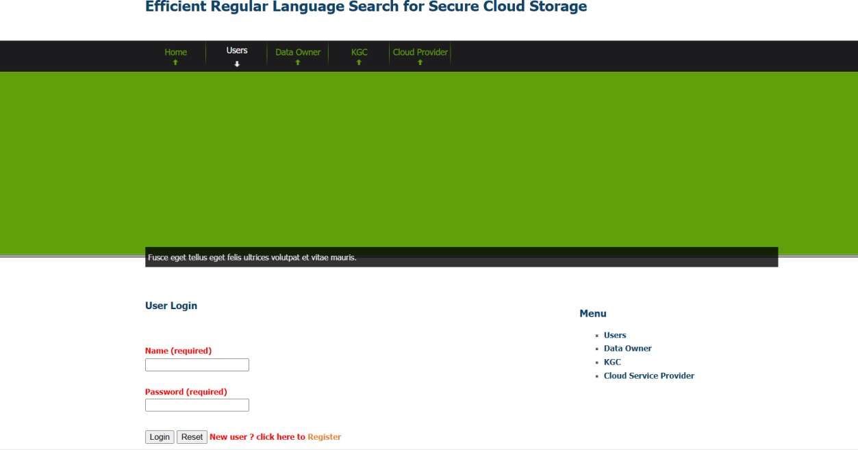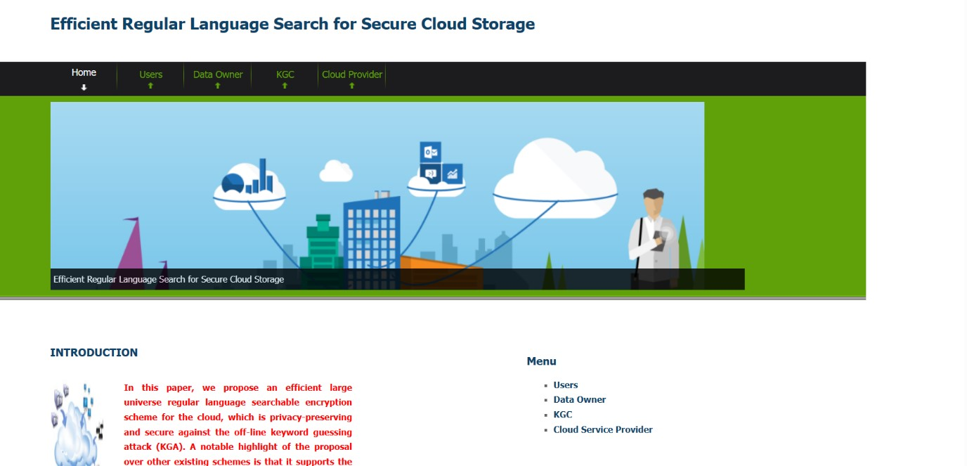

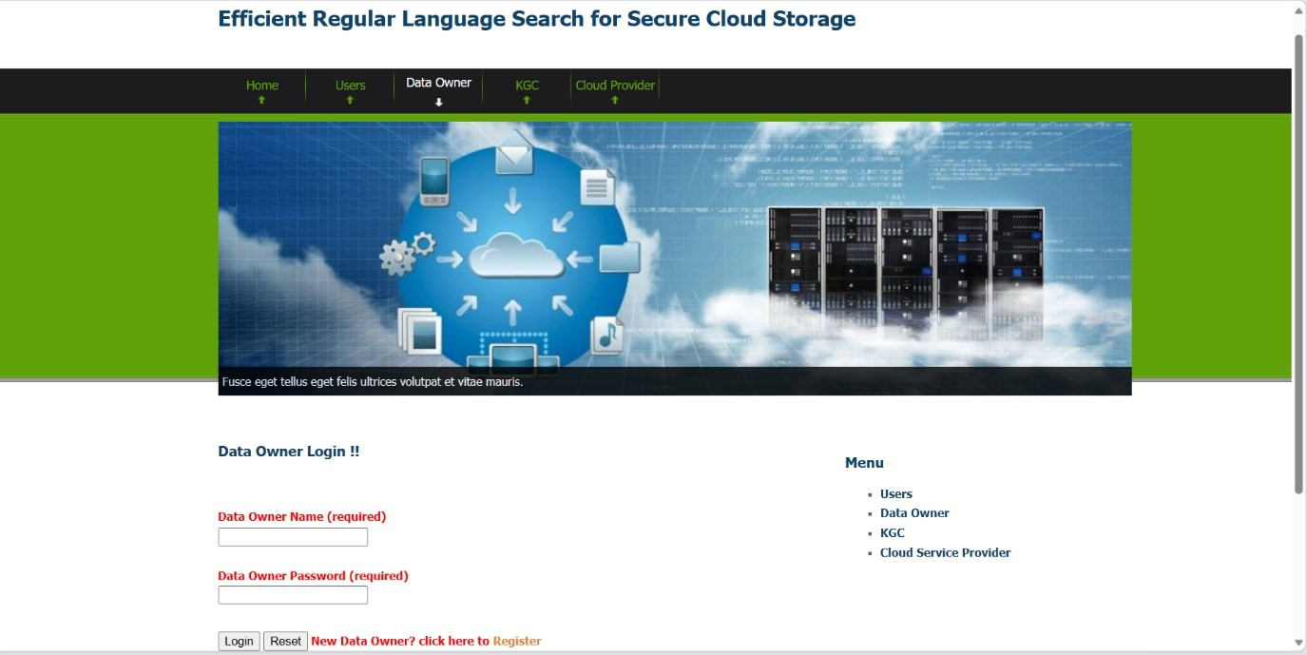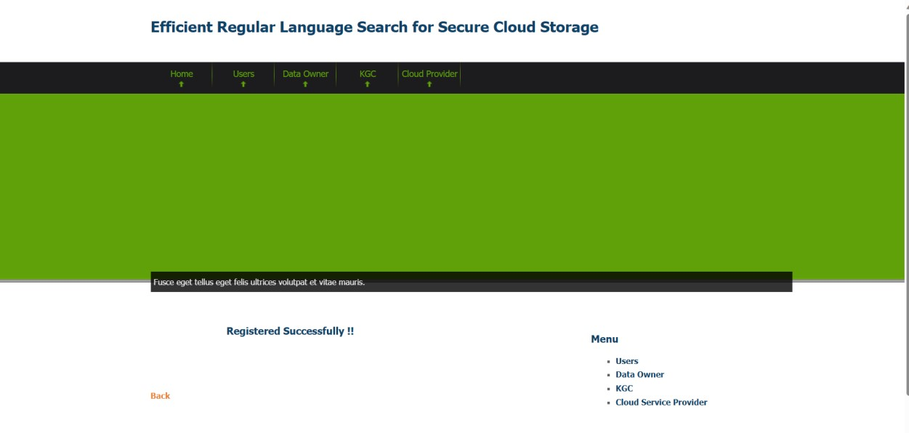

**CONCLUSION:**

To safeguard the integrity of cloud storage systems, we provide in this study a huge universe searchable encryption technique that implements regular language encryption and DFA search functionality. The cloud service provider might check to see if the DFA encoded in the provided search token accepts the encrypted regular language in the encrypted ciphertext. No normal language or DFA plaintext will ever be transmitted in the test method to the cloud server. Additionally, we proposed a physical structure that used efficient token generation and encryption techniques.

An illustration of how the system functions is provided. The suggested approach is proven in the standard model to be with a confidentiality and indistinguishable from KGA.

Low transmission and calculation overhead is confirmed by comparison and experiment results.

**REFERENCES:**

[1] Erl T, Cope R, Naserpour A. Cloud computing design patterns[M]. Prentice Hall Press, 2015.

[2] Li Z, Dai Y, Chen G, et al. Toward network-level efficiency for cloud storage services[M]//Content Distribution for Mobile Internet: A Cloud-based Approach. Springer Singapore, 2016: 167-196.

[3] Sookhak M, Gani A, Khan M K, et al. Dynamic remote data auditing for securing big data storage in cloud computing[J]. Information Sciences, 2017, 380: 101-116.

[4] Zhang Q, Yang L T, Chen Z, Li P. Privacy-preserving doubleprojection deep computation model with crowdsourcing on cloud for big data feature learning[J]. IEEE Internet of Things Journal, 2017, DOI: 10.1109/JIOT.2017.2732735.

[5] Zhang Q, Yang L T, Chen Z, Li P. PPHOPCM: Privacy-preserving High-order Possibilistic c-Means Algorithm for Big Data Clustering with Cloud Computing[J]. IEEE Transactions on Big Data, 2017, DOI: 10.1109/TBDATA.2017.2701816.

[6] Liu J K, Liang K, Susilo W, et al. Two-factor data security protection mechanism for cloud storage system[J]. IEEE Transactions on Computers, 2016, 65(6): 1992-2004.

[7] Boneh D, Waters B. Conjunctive, subset, and range queries on encrypted data[C]//Theory of Cryptography Conference. Springer Berlin Heidelberg, 2007: 535-554.

[8] Q. Zheng, S. Xu, and G. Ateniese. VABKS: verifiable attribute-based keyword search over outsourced encrypted data. In INFOCOM, pp. 522C530. IEEE, 2014.

[9] Liang K, Huang X, Guo F, et al. Privacy-Preserving and Regular Language Search Over Encrypted Cloud Data[J]. IEEE Transactions on Information Forensics and Security, 2016, 11(10): 2365-2376.

[10] Chang V, Ramachandran M. Towards achieving data security with the cloud computing adoption framework [J]. IEEE Transactions on Services Computing, 2016, 9(1): 138-151.

[11] Zheng X H, Chen N, Chen Z, et al. Mobile cloud based framework for remote-resident multimedia discovery and access[J]. Journal of Internet Technology, 2014, 15(6): 1043-1050. [12] Chang V, Kuo Y H, Ramachandran M. Cloud computing adoption framework: A security framework for business clouds [J]. Future Generation Computer Systems, 2016, 57: 24-41. [13] Barsoum A. Provable data possession in single cloud server: A survey, classification and comparative study[J]. International Journal of Computer Applications, 2015, 123(9).

[14] Wang H. Identity-based distributed provable data possession in multicloud storage[J]. IEEE Transactions on Services Computing, 2015, 8(2): 328-340.

[15] J, Tan X, Chen X, et al. Opor: Enabling proof of retrievability in cloud computing with resource-constrained devices[J]. IEEE Transactions on cloud computing, 2015, 3(2): 195-205. [16] Tiwari D, Gangadharan G R. A novel secure cloud storage architecture combining proof of retrievability and revocation[C]//Advances in Computing, Communications and Informatics (ICACCI), 2015 International Conference on. IEEE, 2015: 438-445.

[17] Omote K, Thao T P. MD-POR: multisource and direct repair for network coding-based proof of retrievability[J]. International Journal of Distributed Sensor Networks, 2015, 2015: 3.

[18] Hopcroft JE, Motwani R, Ullman JD. Automata theory, languages, and computation. International Edition 24 (2006).

[19] Lucas SM, Reynolds TJ. Learning deterministic finite automata with a smart state labeling evolutionary algorithm. IEEE Transactions on Pattern Analysis and Machine Intelligence. 2005 Jul;27(7):1063-74.

[20] Kobayashi K, Imura JI. Deterministic finite automata representation for model predictive control of hybrid systems. Journal of Process Control. 2012 Oct 31;22(9):1670-80. [21] de Parga MV, Garcła P, Lpez D. A polynomial double reversal minimization algorithm for deterministic finite automata. Theoretical Computer Science. 2013 May 27;487:17-22.

[22] Sarkar P, Kar C. Adaptive E-learning using Deterministic Finite Automata[J]. International Journal of Computer Applications, 2014, 97(21).

[23] Fernau H, Heggernes P, Villanger Y. A multi-parameter analysis of hard problems on deterministic finite automata[J]. Journal of Computer and System Sciences, 2015, 81(4): 747-765.

[24] Farmanbar A, Firouzi S, Park S J, et al. Multidisciplinary insight into clonal expansion of HTLV-1Cinfected cells in adult T-cell leukemia via modeling by deterministic finite automata coupled with high-throughput sequencing[J]. BMC medical genomics, 2017, 10(1): 4.

[25] D.X. Song, D. Wagner, A. Perrig, ”Practical techniques for searches on encrypted data”, in: IEEE Symposium on Security and Privacy, 2000, pp. 44-55.

[26] Wang C, Cao N, Ren K, et al. Enabling secure and efficient ranked keyword search over outsourced cloud data[J]. IEEE Transactions on parallel and distributed systems, 2012, 23(8): 1467-1479.